Task No & Title: | BSBCMN211A Participate in workplace safety procedures
Title: | Ergonomics Design an office worksheet
Suitable for Classes: | Certificate II Business Cert II in ICT
Area: | Technology & Enterprise
Teacher: | Mr Peter Faulks
Timeline | 1 Lesson
Date Due: | Today

Task Brief:
Files Required | Software Design or drawing

Items highlighted in yellow are tasks for you to complete
Items in Blue are help tips

ERG100 Ergonomics Design an Office Sample Answer

Contents
A New Office 2
Floor plan 2
The Lobby 2
The Graphics office 2
The Printing and Designing Room 2
The Manager’s Office 3
Specifics 3
Security 3
Hardware 4
Printers 4
iPF650 Large Format Printer 4
ImageRUNNER ADVANCE C5045 Colour 4
Computers 5
Vostro 460 Powered by 2nd Gen Intel® Core™ i7 processor 5
Vostro 230s 5
Mac Mini 5
Miscellaneous 5
Software 6
Graphics 6
Microsoft Office Professional 6
Abode Creative Suite 5 Design Premium 6
Utility 6
Snow Leopard Server 6
Norton Antivirus 360 6
Personnel 6
Ergonomics 6
Training 7
Evaluation 7

A New Office
Of course, one room itself isn’t enough, and even though there wasn’t much room in your initial housing, I’ve managed to make an ergonomic yet sustainable and efficient environment for the workspace.

Floor plan
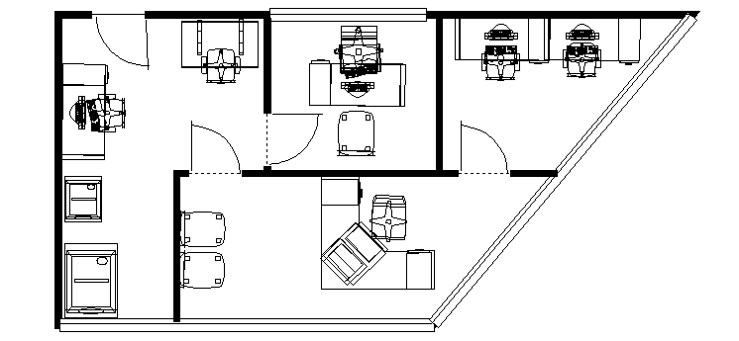
As you can see there are four rooms; the lobby, the Graphics office, the printing and designing room and the manager’s office.

The Lobby
In the lobby is the receptionist’s desk, with chair, and Mac Mini. The two chairs are for waiting clients, however as there are not many clients that meet in person for a business like this, the Receptionist also works with e-mails and phone calls. In the lobby is a very Feng Shui area with a few hangings on the walls, to inspire your clients, they would generally be your work.

The Graphics office
A very simple room containing two desks, two chairs and two computers, The average chair to maintain ergonomics for the designers. Too empty with just two, but too full with three sets, the best way to have this office is to have a very colourful room. Not only will this induce creativity and happiness for the workers, but, as the large window to the outside is right there, it also shows the outside community the designers at work.

The Printing and Designing Room
This room is given to the worker who has the short straw as it is right next to the manager’s office. It contains two printers, one desk, computer and chair, and a drawing table. This is the main planning room, what is betwixt and between the other works. Using the drawing table to plan, and this computer will be the main web designing computer. On the window in this room are advertisements for the business as a whole.

The Manager’s Office
The average “boss” office, daunting desk, computer to the side, two chairs on either side, big leather chair for the manager, and a slightly less fantastical chair for who is interviewing. Not only does this design seem intimidating, but the boss’ computer can always be used for work, and he can receive e-mails and phone calls from this room.

Specifics
This version of the floor plan shows the dimensions of all the walls.
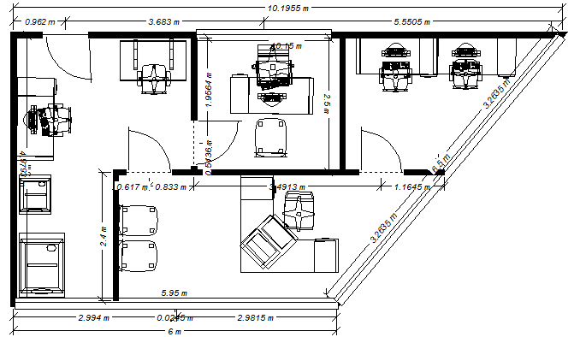
The printers are 1,177w x 870d x 991h mm (the lower printer) and 620 x 760 x 982mm and all other items are standard size. The manager’s office is roughly 2.5 by 2.6 m, the window being 2.5 m, and the other rooms are odd shapes and hard to calculate size.

Security
The shopping mall has many outside cameras facing your ‘shop’; however, they have given a deal to find the cheapest prices for security cameras in your shop that go to the shopping malls security. There will be five cameras, attached to the corners of the ceiling. The cameras are in red, and what they can see is in light yellow. As you can see, the two cameras in the printing and designing room overlap what they see. This is for added protection of the back door.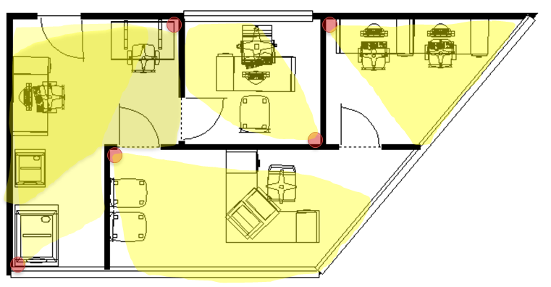

Hardware
Of course, the office needs a lot of hardware as this is an internet designing business. In total there are seven pieces of technology.

Printers
There are two printers one for general printing and scanning (ImageRUNNER ADVANCE C5045 Colour) and the other is a highly professional large graphic printer (iPF650 Large Format Printer)

iPF650 Large Format Printer
“The 24" imagePROGRAF iPF650 is an ideal large format printing solution for personal and small workgroup users in education or office markets. Built for speed, quality and ease of use, the iPF650 is a versatile solution designed to simplify large format printing“ – Canon website
This printer is very large and is made to print large banners or posters. It is a lot smaller than other professional printers of the same calibre, and it is environmentally stable. It comes with accounting software to manage costs and to track use of ink and paper. The front paper system makes it easy to manage the prints. The large LCD control panel ensures user friendliness. The print timer on the screen shows how long a certain job will take. “Hot swap” ink tanks that can be filled whilst printing documents. According to the website, draft A1 prints only take 30 seconds.

ImageRUNNER ADVANCE C5045 Colour
“The imageRUNNER ADVANCE C5045 multifunctional devices are built to support your document workflows and enhance business communication. They offer high productivity and exceptional quality whilst safeguarding your confidential information and providing environmental support.“ - Canon Website
The ImageRUNNER is efficient. It prints up to 45ppm both black and white or colours. It can scan and reuse hard copy documents. It has high speed high quality scanner and copier. It also had advanced fax capabilities. It has true 1200dpi printing, and mixed media support.

Computers
I have selected three different types of computers, and five altogether; one for the manager (and storage), one for the receptionist and three for the workers.

Vostro 460 Powered by 2nd Gen Intel® Core™ i7 processor
Intel(R) Core(TM) Processor i7-2600 (3.4GHz, 8MB, 4C) Genuine Windows® 7 Professional 64-Bit 4GB Dual Channel DDR3 SDRAM at 1333MHz 500GB SATA hard drive (7200RPM) 1024MB AMD RadeonTM HD6670 Trend Micro Worry-Free Business Security Services - 3 licenses - 30 days 1 Yrs Next Business Day Onsite Service 16X DVD+/-RW drive DELL ST2220T 21.5" Multi Touch Monitor
This computer is for the manager; it is very powerful and can hold a lot of data. This is also an archive of older projects.

Vostro 230s
Slim Tower Reliable, Space-Saving Solution for Small Business Intel(R) Core(TM)2 Duo Processor E7500 (2.93GHz, 1066MHz FSB, 3MB L2 cache) Genuine Windows® 7 Professional 32-Bit Dell (TM) 20 " E2011H Wide Screen Flat Panel LCD Monitor 2GB Dual Channel DDR3 SDRAM at 1333MHz 320GB SATA hard drive (7200RPM) Integrated Intel® Graphics Media Accelerator X4500HD Trend Micro Worry-Free Business Security Services - 15 months 1 Yrs Next Business Day Onsite Service 16X DVD+/-RW drive
“From its space-saving design to its ability to integrate with the latest Dell business hardware and services, the Vostro 230s Slim Tower provides a strong foundation for your small business to grow on.” – Dell website.

Mac Mini
“Mac mini features an all-new, 3.6 cm-thin aluminium enclosure. It’s called the unibody — a seamless enclosure carved from a single, solid block of aluminium. The unibody construction was originally developed for Apple’s MacBook Pro. It’s created using computer numerical control, or CNC, machines — the same kind used by the aerospace industry to build mission-critical spacecraft components. This ensures absolute precision of every component of the Mac mini enclosure. Not to mention a stunning aluminium fit and finish that will make any desk proud.” – Mac website

Miscellaneous
Western Digital Terabyte + External hard drive(s) for archiving older projects if needed
A Linksys E3000 Wireless adapter
Model: Linksys E3000
Standards: Draft 802.11n, 802.11a, 802.11g, 802.11b, 802.3, 802.3u, 802.3ab
Ports: Power, Ethernet, Internet, USB
Buttons: Reset, Wi-Fi Protected Setup
LEDs: Power, USB, Internet, Wireless, Wi-Fi Protected Setup, Ethernet (1-4)
Number of Antennas: 3 internal antennas per each 2,4 GHz and 5 GHz radio band
Detachable (y/n): No
UPnP: Supported
Security features: WEP, WPA, WPA2
Security key bits: Up to 128-bit encryption

Software
Besides the basic software, for example the OS, the only things I can recommend are four pieces of software that help in day to day tasks that the average graphic team would need in order to complete their tasks set by the clients. Two are for graphics and two are for utility.

Graphics
These two would be for creating the graphics.

Microsoft Office Professional
This piece of software is highly recommended for pamphlets and other magazine type designs. This user friendly software will definitely be a useful tool in a graphic artists’ arsenal.

Abode Creative Suite 5 Design Premium
This software is what will make a design. This is the state of the art graphic manipulation software, and can even create websites.

Utility
These are for security and for server hosting

Snow Leopard Server
“Whether you’re supporting a creative team, a distributed sales force, a class of multimedia students, or just about any small business or workgroup, you know your users need to share information to work effectively. Mac OS X Server makes it easy to share folders and exchange files between Mac and PC systems without the installation of additional software.” – Mac website
Essentially, this is for transporting files and sharing files around the office.

Norton Antivirus 360
Norton Antivirus 360 is an all in one security suite designed for personal firewalls, phishing protection and has the ability to remove malware. This software is the highest rated antivirus software on the market.

Personnel
Of course the personnel need to have some sort of training, and they need to be taken care of, after all, without workers, you’d be back to square one. Whilst the IT technician doesn’t spend much time inside the shop, the graphic artists and receptionist do. They all need sufficient training and to have enough space for ergonomics.

Ergonomics
Chair backs need to be 90 degrees and the workers need to be 18-24” away from the screen. I have given sufficient space in every office for a worker to stand up and stretch if they need it. Whilst all the chairs and computer monitors are ergonomically set, and can be customized for the shape and size of your workers.

Training
Your workers need to be trained to use at least five programs. These programs include Fireworks, Photoshop, Illustrator, InDesign and Adobe Acrobat. The rest of the programs are fairly user friendly, but these five are especially important.

Evaluation
Yes, the ideal office is an expensive one, but the better looking and better quality your office and workers are, the better your business will boom, and you will get lots of clients.

